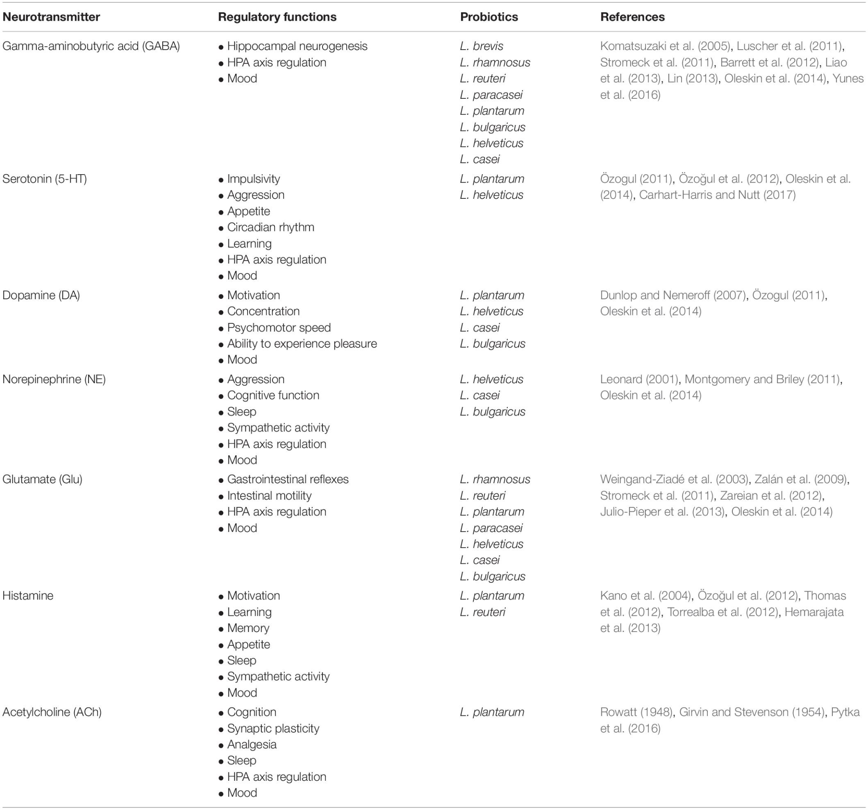

Source: <https://www.frontiersin.org/articles/10.3389/fnins.2019.01361/full>